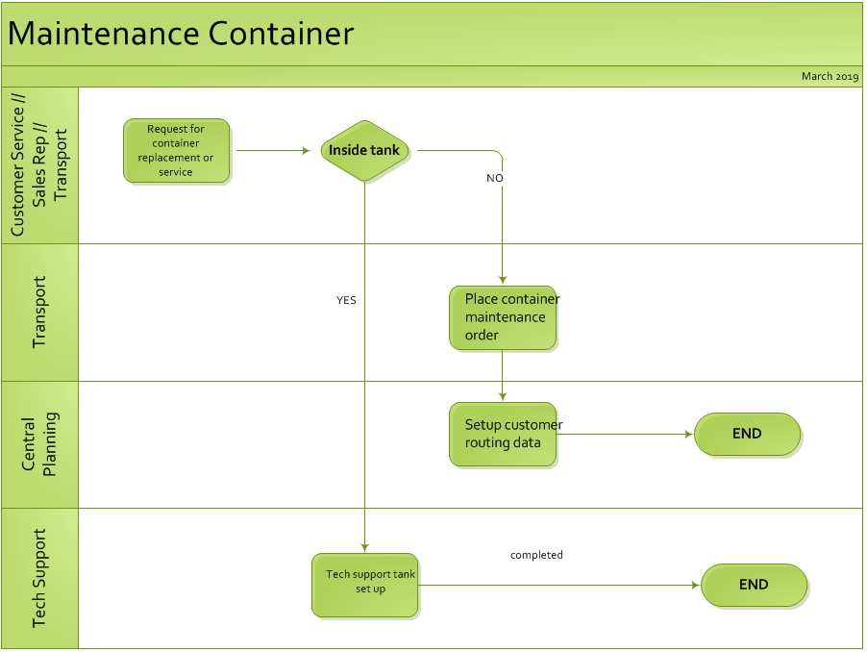

Revision History
REV | RELEASE DATE | ORIGINATOR | REASON FOR CHANGE(S)
A | May 2018 | Marisa Pasquale | Initial Release
A.1 | Sept 10 2018 | Nathalie Harvey | Notice of process merge CAN USA
B | Nov 30 2018 | Nathalie Harvey | ADD CSD – Transport support
C | March 2019 | Ashley Peterson | Add – Central Planning (TOPS)
D

