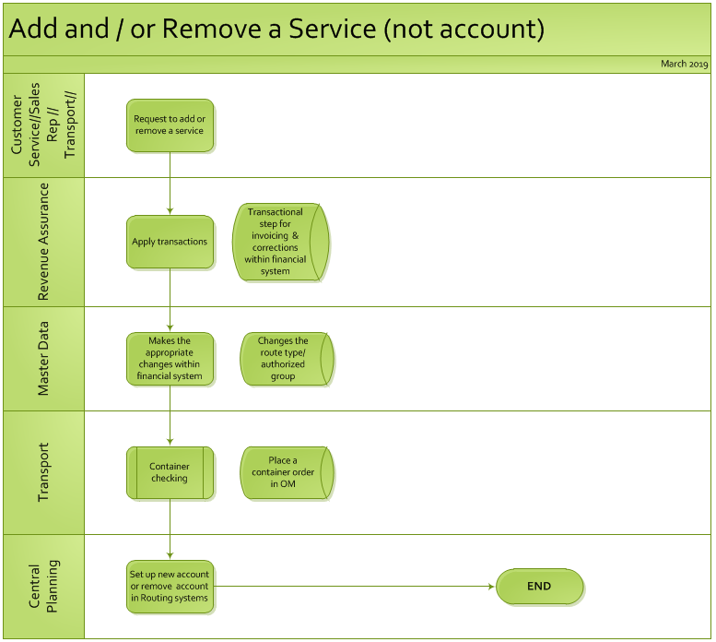

Revision History
REV | RELEASE DATE | ORIGINATOR | REASON FOR CHANGE(S)
A | May 2018 | Marisa Pasquale | Initial Release
B | Nov 30 2018 | Nathalie Harvey | Add : CSD (transport support)
C | March 2019 | Ashley Peterson | Add – Central Planning (TOPS)
D
E

